Standard Medical Release

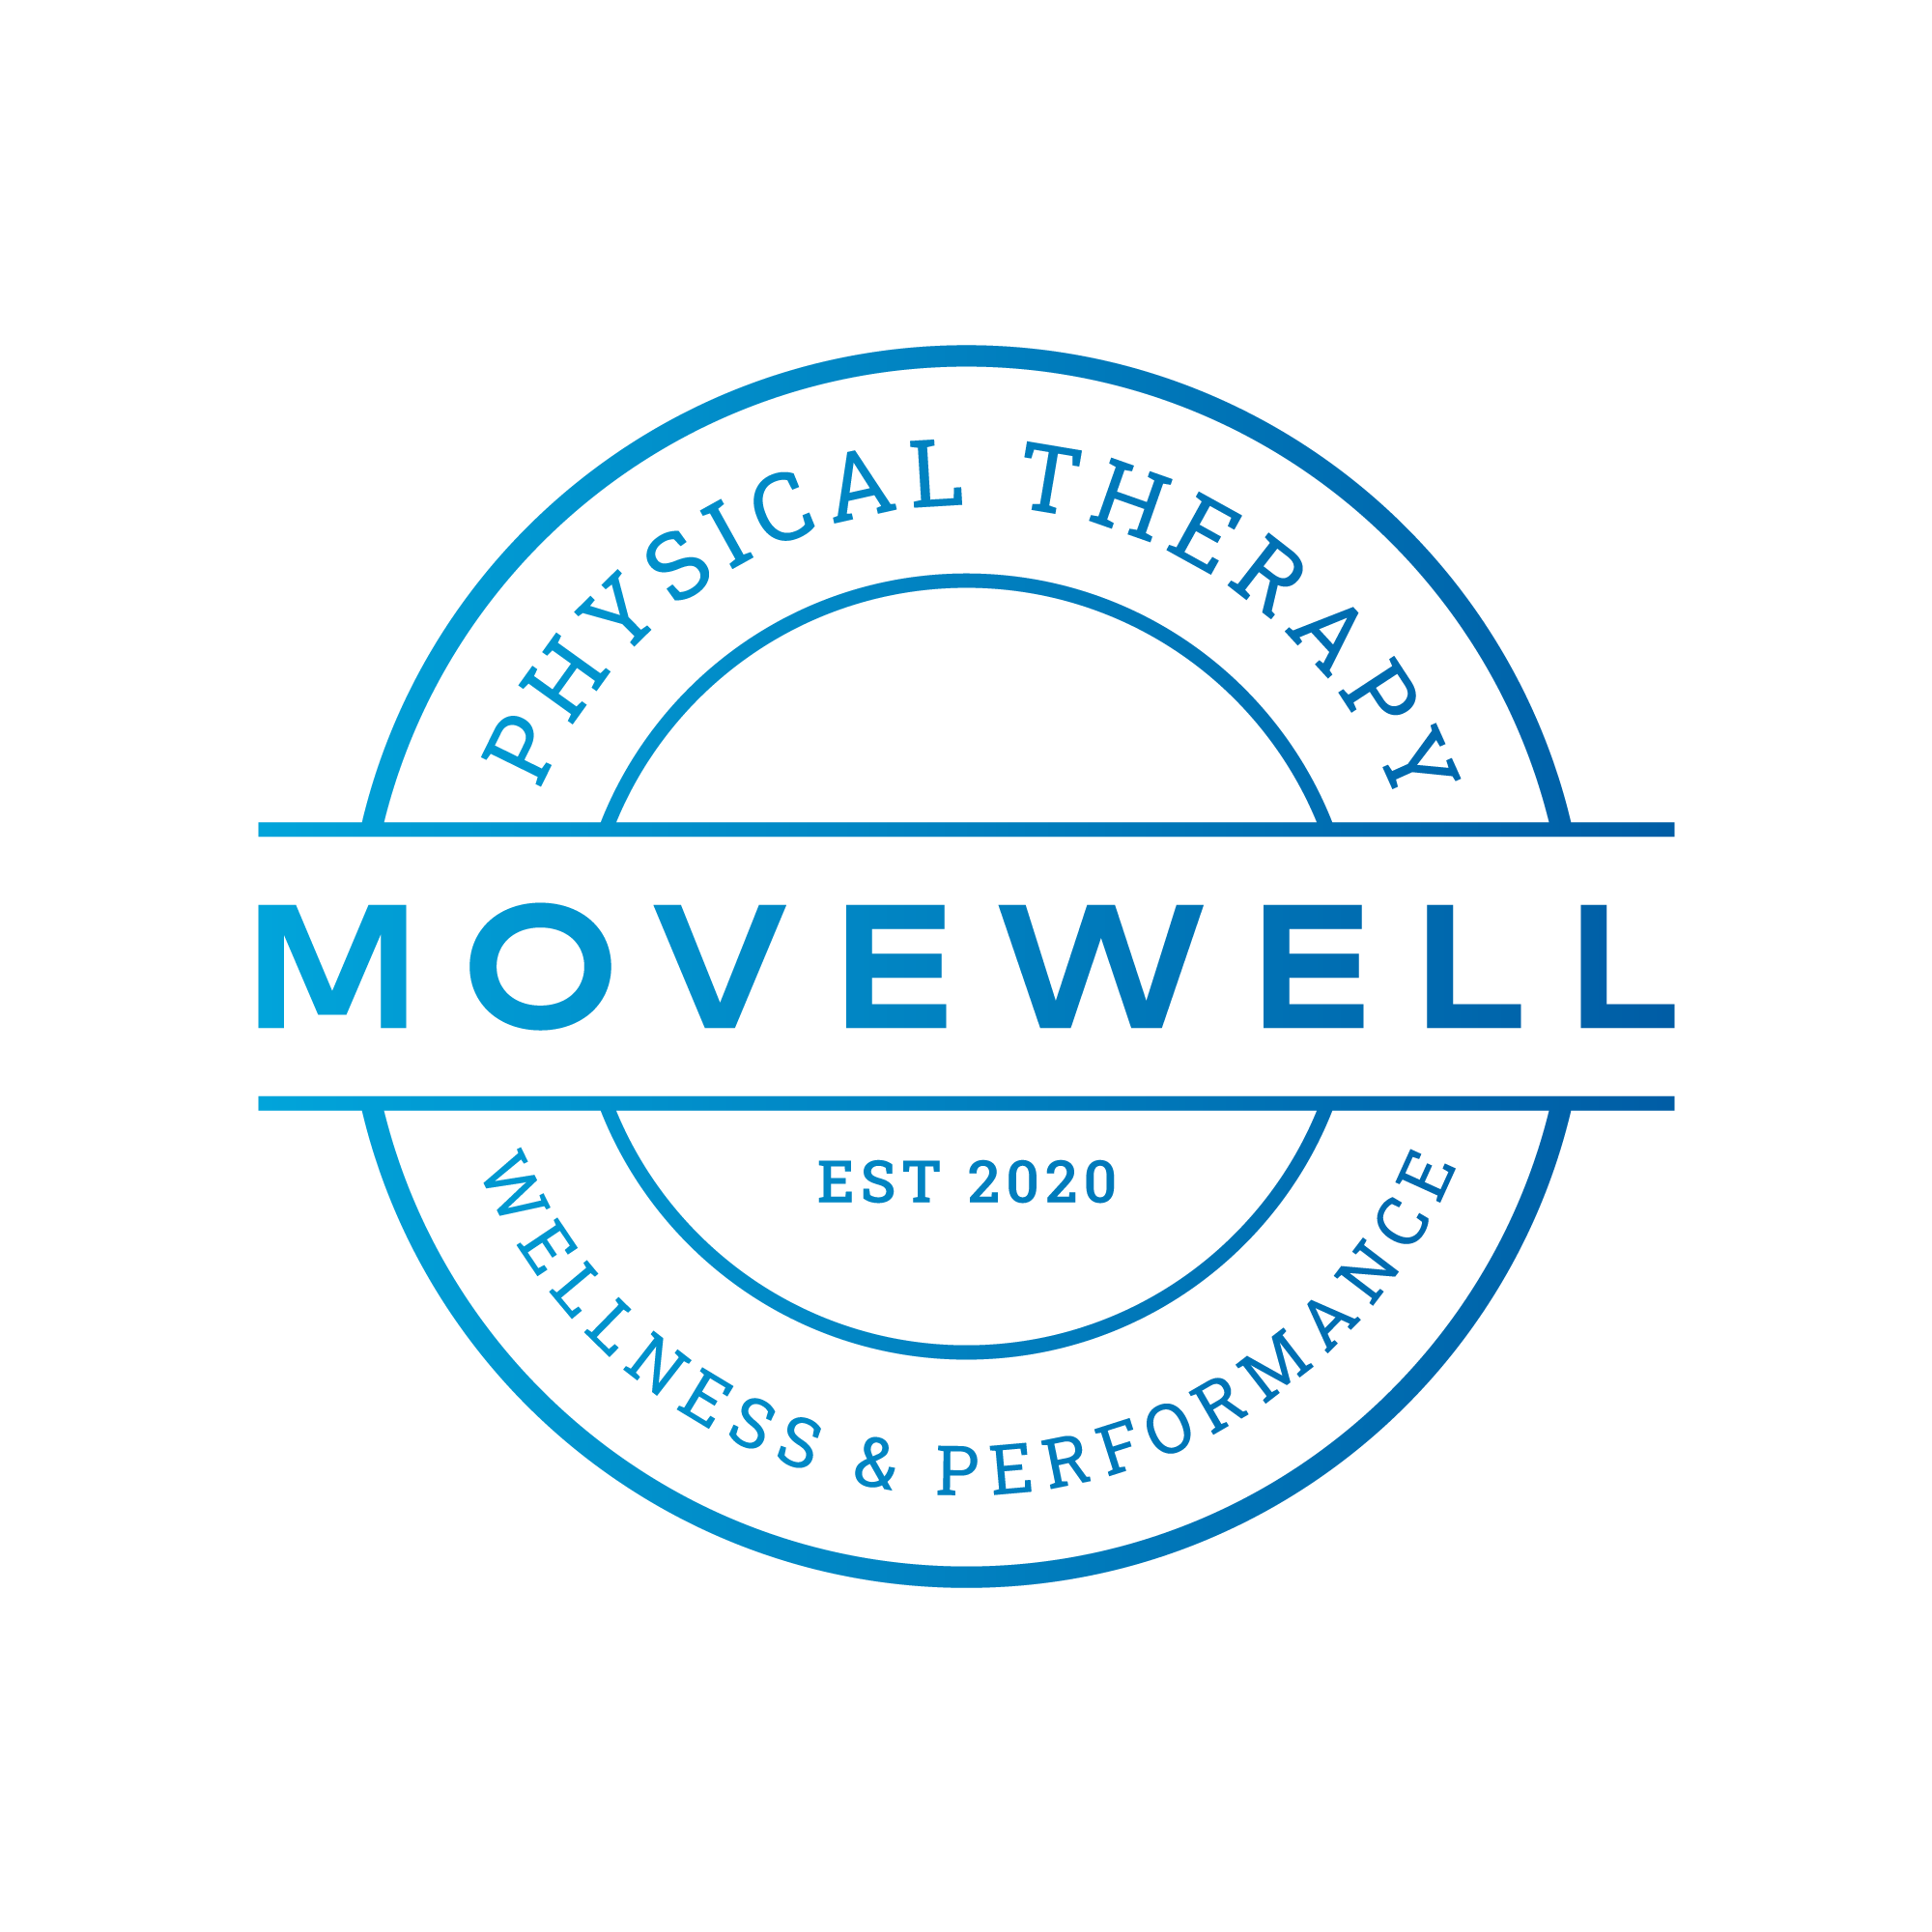
I______________________________, residing at _______________________ State of __________________, acknowledge that I, individually, have voluntarily applied to participate in Movewell Rehab Services sports and agility training program. I acknowledge the risks and potential risks of sports agility training. However, I feel the possible benefits to me and my child are greater than the risk assumed.

I am aware that although Movewell Rehab Services, its owners, employees, and independent contractors make reasonable efforts to make each athlete's training a safe and productive experience, that there are inherent risks which occur as a result of physical activity.

I acknowledge that an athlete, when training, through no fault of his own, his Physical Therapist(s) or the facility may become injured for a variety of reasons that are unavoidable.

I represent that I am in good health and suffer from no physical impairment which would limit my use of Movewell Rehab Services facilities or instruction. I further represent that I carry full and complete medical insurance coverage.

In consideration of being permitted by Movewell Rehab Services to participate in its training program and to use it facilities, I hereby, intending to be legally bound for myself, my heirs and assigns, executors or administrators and/or guardian of my son/my daughter ward specifically agree that Movewell Rehab Services, its officers, employees, and agents shall not be liable for any claim, demand, cause of action of any kind whatsoever for, or on account of death, personal injury, property damage, or loss of any kind resulting from or related to my use of the facilities or participation in any sports agility training, exercise, or activity within or outside the club premises, and I agree to hold Movewell Rehab Services harmless from same. I hereby waive any and all claims for any and all injuries I may suffer under any circumstances, including, but not limited to those claims arising from the negligence of Movewell Rehab Services, its owners, employees and independent contractors, or otherwise.

Athlete's Signature_______________________________________ Date:_______________

Parent/Guardian's Signature_______________________________ Date:_______________

Promotional Release

In additional consideration of being permitted by Movewell Rehab Services to participate in its training program and to use its facilities, I hereby permit Movewell Rehab Services to use my name, image and likeness for promotional mediums including but not limited to print, radio, video, television and internet.

I acknowledge that I have read this release and waiver and fully understand its contents. I have been fully and completely advised of the potential dangers incidental to engaging in the activity and instruction of sports agility training and I am fully aware of the legal consequences of signing this release. I voluntarily agree to the terms and conditions stated above.

Athlete's Signature_______________________________________ Date:_______________

Parent/Guardian's Signature_______________________________ Date:_______________

